## 

## 

## Reusable Rentals Use Agreement

**SUBMIT YOUR COMPLETED FORM TO:** [**info@azulitaproject.org**](mailto:info@azulitaproject.org)

Date signed: _____________________

This agreement is between the Azulita Project Inc. and ________________________________, named as Event Host in this document.

**Event Name and Organization:**

**Event Host Email and Phone:**

**Event Date:**

**Delivery Date:**

**Return Date:**

*Azulita team members will coordinate delivery and return locations with the Event Host.*

Azulita Project is a 501c3 nonprofit that offers Reusable Rentals as a FREE service to our community. Azulita Project requires reimbursement for any lost or damaged items.

**We ask that you consider making a donation to the Azulita Project to help support our waste reduction work.** [**www.azulitaproject.org/give**](http://www.azulitaproject.org/give)

**Available Tableware**

| **Type** | **Replacement Cost** | **Inventory Available** | **Quantity Requested** |
| --- | --- | --- | --- |
| 12 oz. Cocktail Cups Clear Plastic **Cups** | $3 | 150 |  |
| 16 oz. Pint Cups Clear Plastic **Cups** | $4 | 300 |  |
| 16 oz Klean Kanteen Stainless Steel **Cups** | $10 | 200 |  |
| 16 oz. Preserve 100% Recycled Opaque Plastic **Cups** | $2 | 120 |  |
| Large (white) Corelle 10.25" Dinner **Plates** | $6 | 200 |  |
| Small (white) Corelle 6.75" Appetizer **Plates** | $6 | 200 |  |
| Metal Forks | $1 | 250 |  |
| Metal Spoons | $1 | 250 |  |
| Metal Knives | $1 | 250 |  |
| Water Station | $100 | 2 |  |

**The Event Host agrees to the following:**

* Provide clear communication with the Azulita team to coordinate Reusable Rentals delivery and return.
* Engage in a brief info session with the Azulita team for tips on how to run a successful Reusable Rentals event.
* Let guests know ahead of time of your zero waste plans (e.g. include in your marketing or invitations) and make an announcement at your event to educate attendees where to return cups, etc.
* Manage waste stations to capture any reuse ware accidentally tossed into the recycling/trash. Set up return stations and display Azulita Reusable Rentals signage at the event.
* Return Reusable Rentals items in good condition, including signage; count items upon delivery and upon return.
* **The Event Host agrees to follow the dishwashing guidelines outlined below. This sanitizing process is required by Coconino County Health and Human Services.**

**Dishwashing Guidelines**

* **Do not use bleach cleaning products with our plastic ware.** Bleach will ruin the cups and we will have to charge a replacement fee.
* All of our items are dishwasher safe.
* Please thoroughly dry all items before repacking. Air drying is an approved method. Please ensure items are free of water spots.
* Allow all items to thoroughly **cool** before repacking as hot cups may stick together. We charge a replacement fee for all cups that are returned stuck together.
* If handwashing, please follow the three sink method detailed below **(approved sanitizer available upon request)**.
* Clean dishware must be transported in clean, closed tubs/totes.

**Dishwashing method (hand/dishwasher) used:______________________________**

**Location of dishwashing: ________________________________________________**

* **Azulita offers dishwashing services for $10 per 25 items** (please round up to the nearest multiple of 25). If requesting this service, please indicate the total amount here: $__________. Payment is due prior to Reusable Rental delivery.
* If selecting to **pay for our dishwashing service, please ensure all items are free of food debris** before repacking.

___________________________________________________________

Event Host signature and date

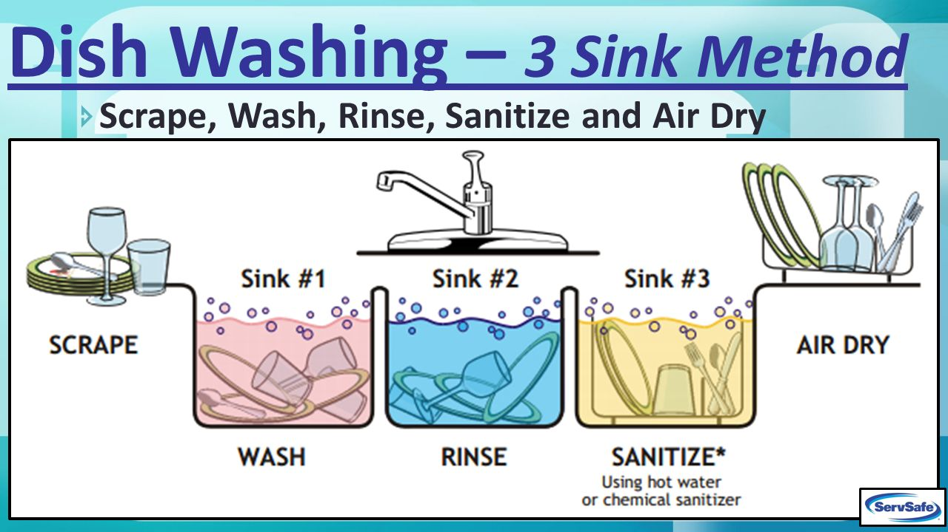

Dishwashing Guide

**Step 1: Pre-Wash**

Scrape off any visible and heavyset food scraps or residue. This will help keep the dish water clean before placing the dish in the basin.

**Step 2: Wash**

Ensure that each basin is clean and sanitized prior to filling them with water. The 1st basin is for washing with hot, soapy water between 95⁰and 120⁰ F. Scrub the dish or cup thoroughly until all remnants of food and residue are gone. Replace water when it becomes too cold or dirty.

**Step 3: Rinse**

The 2nd basin is to be filled with hot water at least 120⁰ F. The cleaned dish or cup should be rinsed in this basin until no more detergent is present on the dish. If it becomes difficult to get the detergent off, you should refill the basin with new, hot water.

**Step 4: Sanitize**

Health code requires this last step to ensure thoroughly cleaned tableware. The 3rd basin should be filled with sanitizer to remove all remaining bacteria from the surfaces. The dish should soak in the sanitizer mixture for at least one minute.

**Step 5: Air Dry**

Do not wipe down the dish with a towel. Simply let the dish or cup air dry until leftover water has dried. Tip: Shake excess water after removing from sanitizer to speed up drying process